Huge Red Button

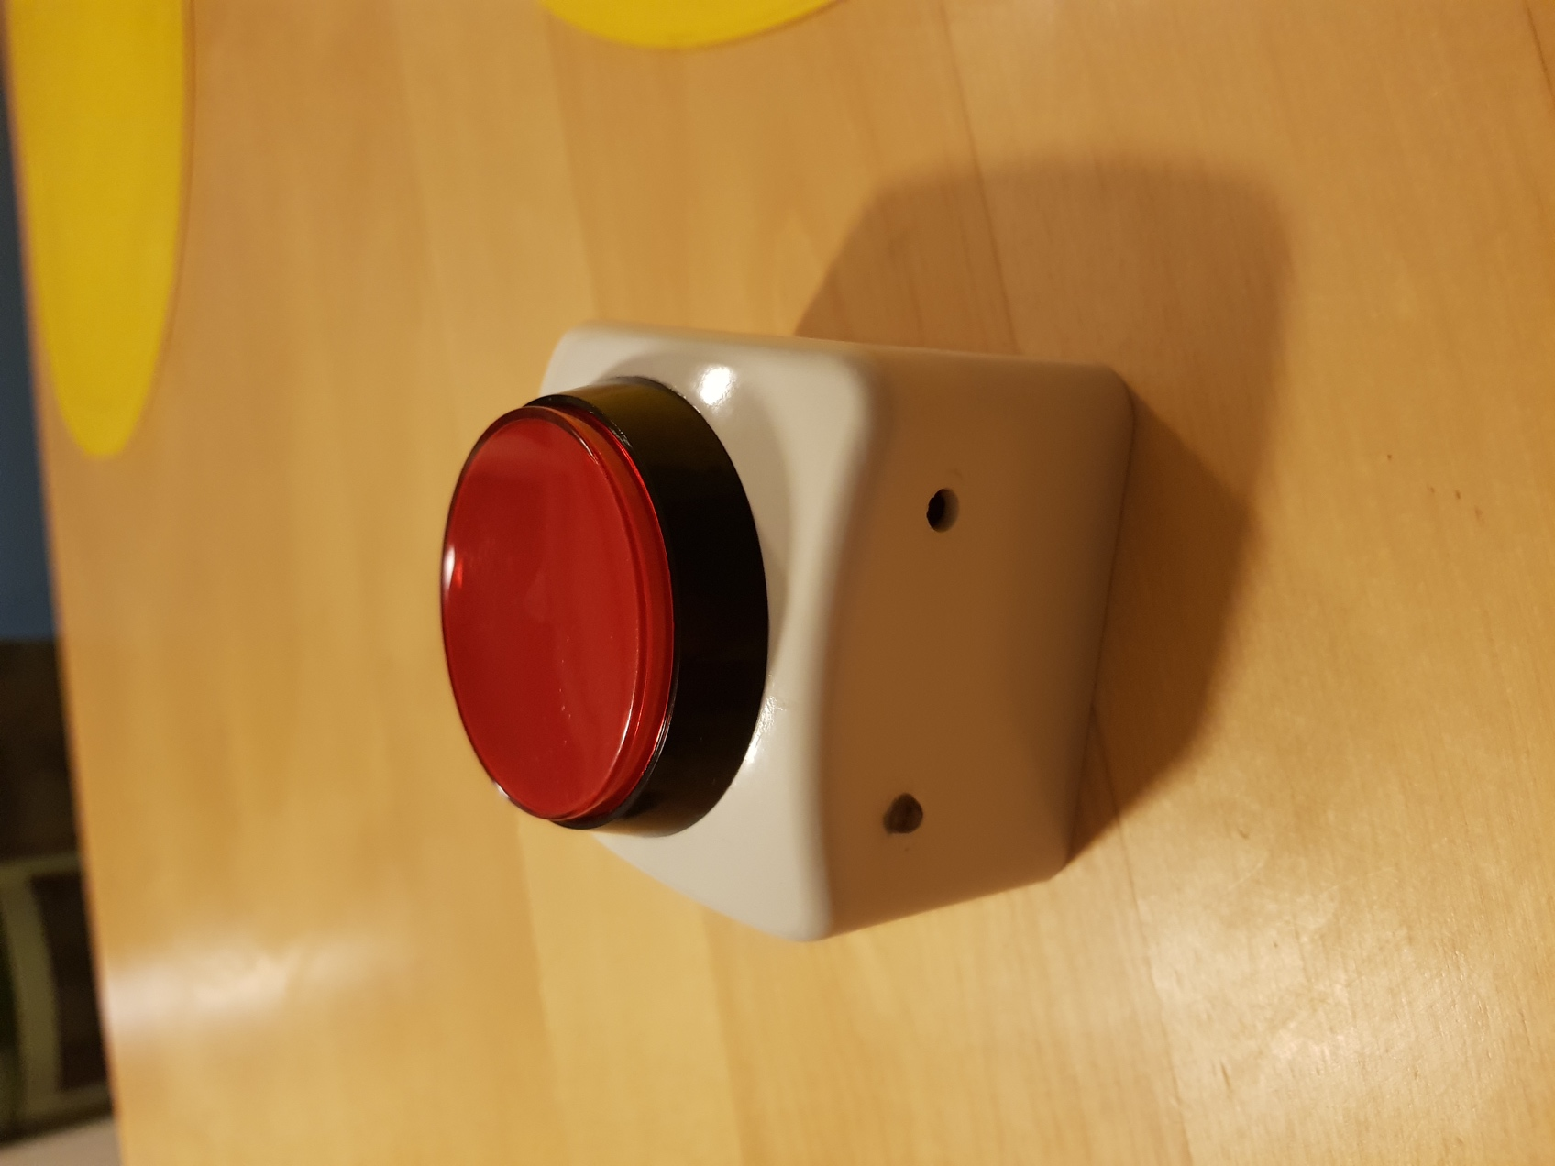

Autor: Enrico Cirignaco

Starts Project: 25.10.2018

Version: 0.1

Abstract: This Device can replicate any button of a TV remote by pressing the Huge Red Button

Summary

1 Introduction 3

2 Concept 3

3 Main Part 3

3.1 Huge Red Button 3

3.2 Electronics 3

3.2.1 Microcontroller 3

3.2.2 IR Receiver - Transmitter 4

3.2.3 Pairing Button 4

3.2.4 9V Battery 4

3.2.5 Schema 4

3.3 Software 4

3.3.1 Sleep Mode 4

3.3.2 EEPROM 5

3.3.3 IOs 5

4 Testing 5

5 Costs 5

# Introduction

This device is designed for aged people that cannot see so much anymore. Because of that the button must be huge. The device must run out of a battery. It must be programmable by entering a “pairing mode”

# Concept

The device will be powered by a 9V battery. It will have an IR-sensor to communicate with the remote and an IR-transmitter to communicate with the TV. The case must be ergonomic and as simple as possible.

# Main Part

## Huge Red Button

The point of the whole project is to make easier to find a button, so it’s very important that the button is as big as possible and has a bright color.

This was the best choice:

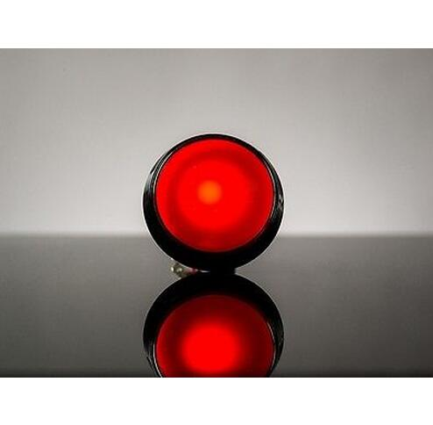

## Electronics

### Microcontroller

The brain of the device is an Arduino Pro Mini with an Atmega 328P microcontroller on it. This was the best option because of its size and because it has a build-in voltage regulator with a very low Quiescent Current. That’s very important because the device will stay 24/7 On. Two versions of this board are available, one with 5V as VCC and 16MHz clock speed and another one with 3V3 as VCC and 8MHz clock speed. The clock speed is in this application irrelevant, so the decision was to take the 3V3 version because it has a lower power consumption.

### IR Receiver - Transmitter

Both an IR receiver and transmitter are needed. The Receiver will read the signal to replicate, coming from the remote. The signal will then be resent with the transmitter. The decision was to buy a breakout board with the IR diodes on it. The boards are easier to mount, and the limiting resistors are already mounted.

### Pairing Button

A classic THT push-button is soldered direct to the board thought a header.

### 9V Battery

The device will be powered by a 9V Battery. The battery must be connected to the RAW pin of the Arduino. This is the only pin that support Voltage above 3.3V.

### Schema



## Software

The program is very simple. As long as the Huge Red Button stay pressed the signal will be sent. To enter pairing mode and register a new signal the Huge Red Button and the pairing button must be pressed at the same time. The System stay in pairing mode until a signal is read by the IR-sensor.

### Sleep Mode

To minimize the power consumption the uC will be put to sleep when possible. Also, the Watchdog Timer can be turned off. The processor will wait for an Interrupt on a digital pin (connected with the Huge Red Button) for waking up. If all the tasks are done it will go to sleep again.

### EEPROM

After a new signal is registered, it’s important to save it on the EEPROM so if the device is turned off or restarted, the signal will not get lost. Before escaping pairing mode, the signal is saved in the EEPROM of the Arduino. On boot up in the setup section the signal will be loaded in the right variable.

### IOs

The two Buttons and the IR-boards are connected to the IOs of the Arduino. Also, the power supply of the two board is connected to the IOs. So, no ports are constantly connected to the power supply.

# Testing

After Assembling all the components together some test and a lot of debugging is done.

In the Table below is showed the current consumption in different scenario.

|  |  |  |  |
| --- | --- | --- | --- |
|  | Voltage (VDC) | Current (mA) | Power Consumption (uW) |
| Standby | 9.43 | 0.070 | 660.00 |
| Pressing HRB | 9.43 | 4.600 | 43400 |
| Pairing | 9.43 | 6.000 | 56580 |

Assuming that the system is powered with a 9v battery with 600mAh capacity the device can stay in standby for around 8.573 hours (357 days) after the battery need to be replaced.

# Costs

Here is an account of the costs for all the components needed to assembly the device.

|  |  |  |
| --- | --- | --- |
| Item | Cost in USD | Shop |
| Arduino Pro Mini (8Mhz) | 1.66 | [Aliexpress](https://www.aliexpress.com/item/1pcs-lot-Pro-Mini-Module-Atmega328-5V-16M-with-Arduino-Compatible-With-Nano/32672852945.html?spm=a2g0s.9042311.0.0.27424c4djZFdmN) |
| IR receiver Board | 0.69 | [Aliexpress](https://www.aliexpress.com/item/IR-Infrared-Transmitter-Module-IR-Digital-38KHz-Infrared-Receiver-Sensor-Module-Infrared-Sensor-Module-Electronic-Building/32917596830.html?spm=a2g0s.9042311.0.0.27424c4djZFdmN) |
| IR transmitter Board | 0.73 | [Aliexpress](https://www.aliexpress.com/item/IR-Infrared-Transmitter-Module-IR-Digital-38KHz-Infrared-Receiver-Sensor-Module-Infrared-Sensor-Module-Electronic-Building/32917596830.html?spm=a2g0s.9042311.0.0.27424c4djZFdmN) |
| 9V DC Battery Power Cable | 0.25 | [Aliexpress](https://www.aliexpress.com/item/9V-DC-Battery-Power-Cable-Plug-Clip-Barrel-Jack-Connector-for-Arduino-DIY-I-T-type/32828564174.html?spm=a2g0s.9042311.0.0.27424c4dLmonSd) |
| 9V Battery | 1.52 | [Aliexpress](https://www.aliexpress.com/item/New-6F22-PPP3-6lr61-9V-battery-Super-Heavy-Duty-Dry-Batteries-Non-Rechargeable-For-Radio-Camera/32934607716.html?spm=a2g0s.9042311.0.0.27424c4dLmonSd) |
| Huge Red Button | 1.60 | [Aliexpress](https://www.aliexpress.com/item/5-Colors-LED-Light-Lamp-60MM-Big-Round-Arcade-Video-Game-Player-Push-Button-Switch/32827197328.html?spm=a2g0s.9042311.0.0.27424c4djZFdmN) |
| Enclosure | - | - |